OV Wildcard SSL/TLS certificate
# Source: AI Source: Provided by: [Data Path: Persons Table -> ID Column: 1, Name_En Column: Motasem Essam] -> From: [ChatGPT] on [1/18/2026]
An OV Wildcard SSL/TLS certificate combines Organization Validation (OV) with Wildcard support, meaning it verifies both the domain and the real organization behind it, while securing all first-level subdomains of that domain.

🔐 What OV Wildcard Means
# Source: AI Source: Provided by: [Data Path: Persons Table -> ID Column: 1, Name_En Column: Motasem Essam] -> From: [ChatGPT] on [1/18/2026]
- OV (Organization Validation) → verifies company identity
- Wildcard (*) → covers unlimited first-level subdomains
- Provides higher trust than DV Wildcard
Example
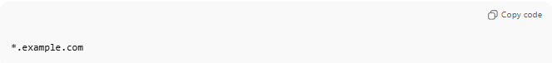
*.example.com
This secures:
- www.example.com
- api.example.com
- mail.example.com
❌ Does not secure:
- example.com (unless added separately)
- dev.api.example.com (second-level subdomain)

🛠️ How OV Wildcard Is Issued
# Source: AI Source: Provided by: [Data Path: Persons Table -> ID Column: 1, Name_En Column: Motasem Essam] -> From: [ChatGPT] on [1/18/2026]
The Certificate Authority (CA) verifies:
- Domain ownership (DNS validation)
- Organization identity, including:
  - Legal business registration
  - Physical address
  - Operational existence
  - Authority of requester
⏱️ Issuance time: Hours to a few days

📍 Where OV Wildcard Certificates Are Used
# Source: AI Source: Provided by: [Data Path: Persons Table -> ID Column: 1, Name_En Column: Motasem Essam] -> From: [ChatGPT] on [1/18/2026]
- Business websites with many subdomains
- SaaS platforms
- Corporate portals
- APIs handling customer data
- Enterprise environments

✅ Advantages
# Source: AI Source: Provided by: [Data Path: Persons Table -> ID Column: 1, Name_En Column: Motasem Essam] -> From: [ChatGPT] on [1/18/2026]
- Higher trust than DV Wildcard
- Verified organization details in certificate
- One certificate for unlimited subdomains
- Strong phishing resistance

⚠️ Limitations
# Source: AI Source: Provided by: [Data Path: Persons Table -> ID Column: 1, Name_En Column: Motasem Essam] -> From: [ChatGPT] on [1/18/2026]
- More expensive than DV Wildcard
- Longer issuance time
- Private key compromise affects all subdomains
- No EV-level branding or indicators

🔒 Best Practices
# Source: AI Source: Provided by: [Data Path: Persons Table -> ID Column: 1, Name_En Column: Motasem Essam] -> From: [ChatGPT] on [1/18/2026]
- Use for subdomains with similar trust levels
- Protect the private key carefully
- Separate sensitive systems if needed
- Monitor and renew certificates proactively

🧠 OV Wildcard vs DV Wildcard
# Source: AI Source: Provided by: [Data Path: Persons Table -> ID Column: 1, Name_En Column: Motasem Essam] -> From: [ChatGPT] on [1/18/2026]
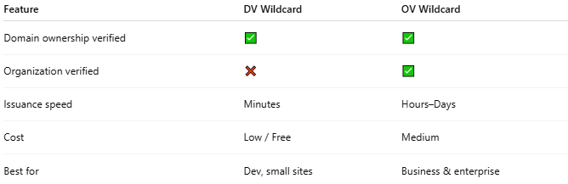
Feature | DV Wildcard | OV Wildcard
Domain ownership verified | ✅ | ✅
Organization verified | ❌ | ✅
Issuance speed | Minutes | Hours–Days
Cost | Low / Free | Medium
Best for | Dev, small sites | Business & enterprise

One-sentence summary
# Source: AI Source: Provided by: [Data Path: Persons Table -> ID Column: 1, Name_En Column: Motasem Essam] -> From: [ChatGPT] on [1/18/2026]
An OV Wildcard certificate verifies the organization behind a domain and secures all first-level subdomains with a single trusted SSL/TLS certificate.

